MUJTABA SHAHID FAIZI

BSCS-5A

131818

LAB 5

WEB ENGINEERING

TASK 1:

<!DOCTYPE html>

<html>

<head>

<title></title>

<style>

body{

width: 200%;

margin: 0;

padding: 0;

background-image:url(14a7918fcdf6dc302c80fa10f1a86a7a_XL.jpg);

background-repeat:no-repeat;

content-align: center;

}

div.container{

width: 90%;

margin: 0 5% 0 5%;

border: 0 solid #DFDFDF;

}

.dropdown {

position: relative;

display: block;

background-color: #DFDFDF;

padding: 0 5% 0 5%;

}

div.dropdown a{

font-size: 30px;

color: #FFFFFF;

margin: 15px 0 15px 0;

font-family:"Arial Black", Gadget, sans-serif;

display: inline-block;

text-shadow: 2px 2px 8px gray;

}

.dropbtn {

cursor: pointer;

height: 50px;

margin: 5px 0px 5px 0px ;

border-radius: 15px;

float: right;

font-family: inherit;

font-size: 20px;

color: #FBFBFB;

border-bottom: 0;

border: 5px;

text-shadow: 2px 2px 8px gray;

}

.dropdown-content {

display: none;

position: relative;

background-color: #DFDFDF;

box-shadow: 0px 8px 16px 0px rgba(0,0,0,0.2);

z-index: 1;

height:0px;

transition: height 2s ease-in-out;

overflow:hidden;

}

.dropdown-content a {

color: black;

padding: 12px 16px;

text-decoration: none;

display: block;

}

.dropdown-content:hover a {

background-color: #AFAFAF;

}

.dropdown:hover .dropdown-content {

display: block;

height:300px;

}

.dropdown:hover .dropbtn {

background-color:#000;

}

</style>

</head>

<body>

<div class="container">

<div class="dropdown">

<a>IMDB</a>

<div class="dropdown-content">

<a href="#">TV</a>

<a href="#">Movies</a>

<a href="#">Celebs</a>

<a href="#">Drama</a>

</div>

</div>

</div>

</body>

</html>\

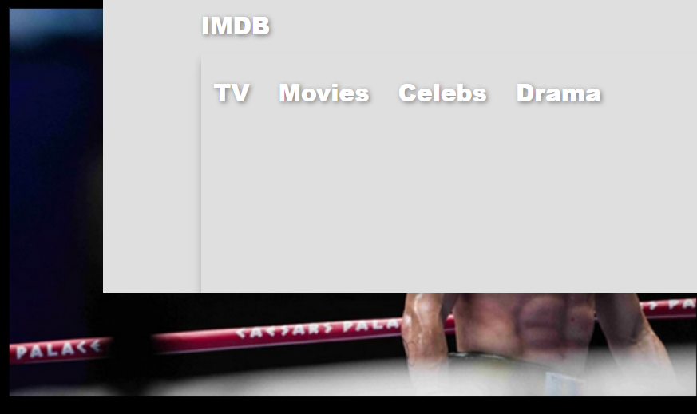

TASK 2:

<!DOCTYPE html PUBLIC "-//W3C//DTD XHTML 1.0 Transitional//EN" "http://www.w3.org/TR/xhtml1/DTD/xhtml1-transitional.dtd">

<html xmlns="http://www.w3.org/1999/xhtml">

<head>

<meta http-equiv="Content-Type" content="text/html; charset=utf-8" />

<title>task1</title>

<style>

div.car{

position: relative;

animation: move 4.0s infinite linear;

animation-direction:alternate;

top: 8px;

left: 16px;

animation-timing-function:ease-in;

}

@keyframes move {

0% {left:0px; top:0px;}

25% {left:100px; top:0px; }

50% {left:200px; top:0px;}

75% {left:300px; top:0px;}

100% {left:400px; top:0px;}

}

.wheel{

position: absolute;

top: 140px;

left: 87px;

width: 130x;

height: 98px;

}

.wheel .front {

position: absolute;

-webkit-animation: spin 0.8s infinite linear;

animation: spin 0.8s infinite linear;

left: 141px;

top: -57px;

width: 130px;

height: 98px;

z-index: 1;

}

@keyframes spin {

0% { transform: rotate(0); }

100% { transform: rotate(360deg);}

}

.wheel .rear {

position: absolute;

-webkit-animation: spin 0.8s infinite linear;

animation: spin 0.8s infinite linear;

top: -50px;

left: -89px;

width: 130px;

height: 98px;

}

</style>

</head>

<body>

<div class="car">

<img src="HU.png" width="359" height="186" alt="car" />

<div class="wheel">

<div class="rear">

<img src="ji.png" width="130" height="98" alt="wheel" /> </div>

<div class="front">

<img src="ji.png" width="130" height="98" alt="wheel" /> </div>

</div>

</div>

<body>

</body>

</html>

</body>

</html>

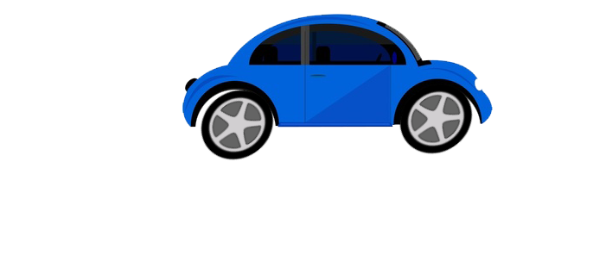

DESCRIPTION: we have used various animations and transitions from css3. Use of various tags and classes aswell to make the webpage presentable.